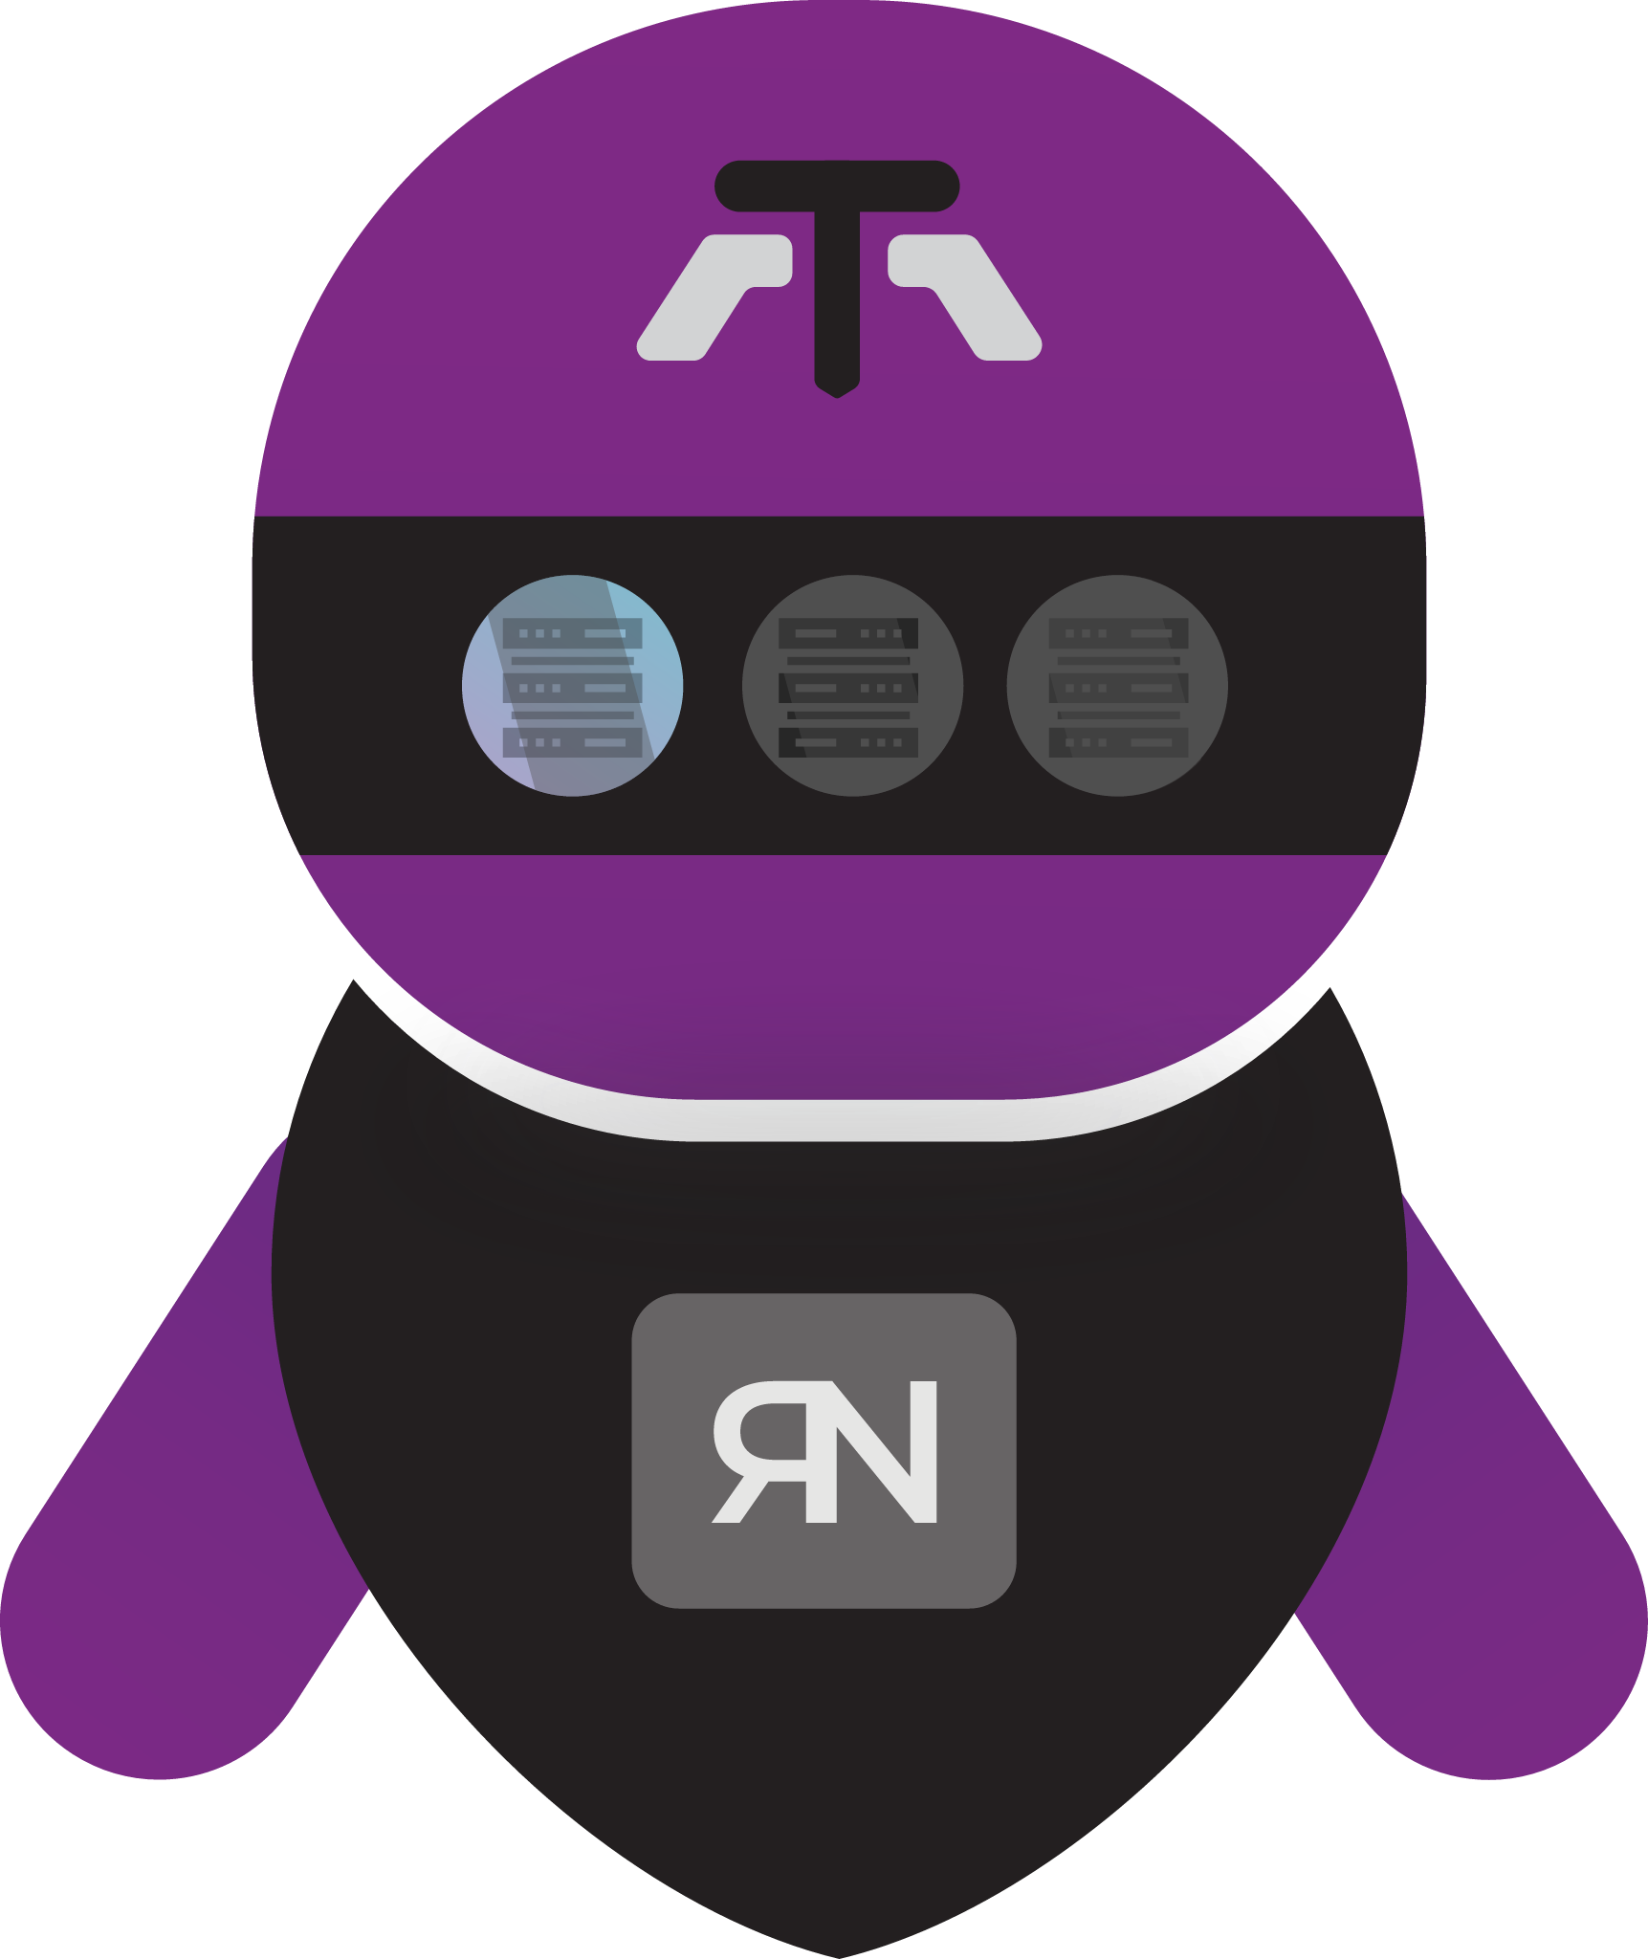



Deployment & Installation Guide

1. What Reflection does
Reflection publishes a TCP or UDP service that is reachable from a public mirror server, while the real service stays on a private reflector server. A reflector creates encrypted control/data channels to the mirror. When a client connects to the published mirror port, Reflection assigns one channel and connects to the configured origin service.

Client → public mirror:published port → encrypted Reflection channel → reflector → private origin service

This is a transport-layer relay. It does not understand HTTP, TLS, databases, or application protocols; it forwards TCP streams or UDP datagrams. Use it only where a reverse TCP/UDP relay is the intended architecture.

2. Components and where they run

Component | Run on | Purpose
Mirror | Public/reachable host | Receives reflector control/data channels and opens the client-facing listener on demand.
Reflector | Network that can reach the origin | Connects to the mirror, maintains a TCP channel pool, and opens connections to the origin.
Origin service | Usually private | The existing TCP/UDP service being made reachable. It is not part of this repository.

3. Requirements
- Node.js with the built-in net, dgram, crypto, cluster, and filesystem modules. The repository has no `package.json` and no third-party Node dependency install step.
- Two hosts with network connectivity from reflector to mirror control/data ports.
- An origin service reachable from the reflector on the configured host and port.
- Permission to listen on the selected ports. Use ports above 1024 unless the service account has the required capability.
- The mirror and reflector must use the same conf/crypt.json values. Control traffic and TCP relay control messages use the shared key; the optional AES extension has its own conf/aes.json secret.
Check Node before deployment:

node --version
node -e "require('net'); require('dgram'); require('crypto'); console.log('Node runtime OK')"

4. Before installation: choose ports and firewall rules
Choose non-conflicting ports. Do not expose the control, heartbeat, or firewall-control ports to the Internet. Restrict them to reflector/admin addresses. The published service port is the only port normally open to clients.

Important UDP Note: The implementation starts its heartbeat server with Node’s TCP net API even for the UDP mode. Keep the heartbeat port reachable over TCP until a future release.

5. Installation
Perform these steps on both hosts.
- Copy the complete reflection directory to a stable location, for example /opt/reflection.
- Create a non-login service account, for example reflection.
- Give that account ownership of the installation and ensure it can create /opt/reflection/logs.
- Keep conf/ readable only by the service account because it contains secrets.

6. Secure the configuration first
The supplied configuration contains sample/default secrets and example addresses. Treat it as a template, not production configuration.
- Generate two new high-entropy secrets: one for key, one for heartbeat_key.
- Put them in conf/crypt.json on both hosts, with identical values.
- If using the AES traffic extension, replace conf/aes.json with the encrypted AES key expected by extensions/aes.js; otherwise do not enable that extension.
- Never put secrets directly in source control. Any string config value may instead use env:VARIABLE_NAME; Reflection resolves it from the process environment at startup.

Example crypt.json pattern using environment variables:
{
"key": "env:REFLECTION_CONTROL_KEY",
"heartbeat_key": "env:REFLECTION_HEARTBEAT_KEY",
"fips_mode": false
}
Set those environment variables in the service manager, not in a world-readable shell file. Both endpoints must receive exactly the same values. If FIPS is enabled on the installation system, then change fips_mode flag as true.

7. Configure a standard TCP relay

7.1 Mirror host: `conf/mirror.json`
Set the bind addresses and shared control ports. A conservative example:
{
"host": "0.0.0.0",
"port": 2000,
"heartbeat_tcp": 2001,
"keep_alive": 1000,
"timeout": 300000,
"firewall_enabled_tcp": false,
"firewall_enabled_udp": false
}
port is the Reflection control/data port, not the client-facing service port. The reflector asks the mirror to create the client-facing listener dynamically. host should be a specific public or private address where possible; use :: only when intentionally accepting IPv6.

7.2 Reflector host: `conf/reflect.json`
For an origin service at 10.0.0.25:8080, published as mirror port 1201:
{
"reflected_host": "10.0.0.25",
"reflected_port": 8080,
"mirror_host": "<mirror_ip>",
"mirror_port": 2000,
"mirror_heartbeat_tcp": 2001,
"mirror_service_host": "0.0.0.0",
"mirror_service_port": 1201,
"mirror_force_listener": true,
"pool_size": 5,
"mirror_connect_timeout": 20000,
"heartbeat_check_interval": 60000,
"dhcp_check": true,
"logfile": "reflector_tcp.log.ndjson"
}
reflected_* identifies the origin from the reflector’s network. mirror_* identifies the mirror control endpoint. mirror_service_* defines the public listener created on the mirror. pool_size is the number of idle TCP channels; it also caps the number of simultaneous TCP client sessions for this mapping. Size it for expected concurrency plus a small buffer.
For IPv4/IPv6 UDP, also set mirror_hostudpv4, mirror_hostudpv6, mirror_service_host_udpv4, mirror_service_host_udpv6, and ipv6enabled appropriately. Disable IPv6 (false) unless both hosts and firewall rules support it.

7.3 Start order and test
Start the mirror first, then the reflector:
cd /opt/reflection
node --env-file=.env mirror_tcp.js
cd /opt/reflection
node --env-file=.env reflect_tcp.js

Do not regard an open TCP port alone as proof of success: confirm an actual application response.
curl -v http://<mirror_ip>:1201/

8. TCP, UDP, and multi-service launch commands
Use case | Mirror command | Reflector command
TCP | node mirror_tcp.js | node reflect_tcp.js
UDP | node mirror_udp.js | node reflect_udp.js
Many TCP mappings | node mirror_tcp.js | node massreflect_tcp.js

Multiple TCP mappings
Use conf/massreflect.json when one reflector publishes multiple origins or multiple reflectors use the same mirror.
Each reflected_hosts string follows this syntax:
"origin-host:origin-port->published-bind-address:published-port"
Can leave the Mirror_hostsudpv6 blank if using ipv4.

[
{
"reflected_hosts": ["216.116.72.174:80->[::]:1201","216.116.72.174:443->[::]:1202"],
"mirror_host": "<mirror_ip>:<mirror_port>",
"mirror_hostsudpv4": "<mirror_ipv4>:<mirror_port>",
"Mirror_hostsudpv6": "<mirror_ipv6>:<mirror_port>",,
"mirror_heartbeat_tcp": 2001,
"mirror_heartbeat_udp": 1002
}
]





Administrator & Operations Manual

9. Configuration reference

`conf/reflect.json`
Key | Meaning
reflected_host, reflected_port | Origin address and port, reachable by the reflector.
mirror_host, mirror_port | Mirror TCP control/data endpoint.
mirror_hostudpv4, mirror_hostudpv6 | UDP mirror addresses.
mirror_heartbeat_tcp, mirror_heartbeat_udp | Mirror heartbeat ports.
mirror_service_host, mirror_service_port | TCP public bind address and port created on the mirror.
mirror_service_host_udpv4, mirror_service_host_udpv6 | UDP public bind addresses.
mirror_force_listener | Replaces an existing listener for the mapping when true; avoid sharing a published port between reflectors.
pool_size | Idle TCP channel count / per-mapping concurrency ceiling.
mirror_connect_timeout | Control/UDP connection timeout in milliseconds.
heartbeat_check_interval | Heartbeat interval in milliseconds.
mirror_heartbeats_lost_for_exit | Consecutive failed beats tolerated before exit; supervisor should restart it.
dhcp_check, dhcp_check_interval | Exits when non-internal network interface addresses change; enable when a supervisor will restart after address changes.
reflector_channel_check_wait | Exit if the TCP channel pool is empty longer than this many milliseconds.
keep_alive | TCP keepalive delay in milliseconds; use -1 to skip.
ipv6enabled | Enables UDP IPv6 socket use.
udp_cleanup_interval | Idle UDP mapping cleanup time in milliseconds; -1 means no cleanup.
logfile | TCP reflector log filename below logs/.

`conf/mirror.json`
Key | Meaning
host, port | TCP mirror bind address and Reflection control/data port.
hostudpv4, hostudpv6 | UDP bind addresses.
heartbeat_tcp, heartbeat_udp | Heartbeat server ports.
keep_alive, timeout | TCP channel keepalive and idle timeout.
udp_cleanup_interval | Idle UDP client mapping cleanup period.
ipv6enabled | Whether mirror UDP also binds IPv6.
firewall_* | Optional admission-control settings; see next section.

Worker and logging configuration
cluster_reflector.json and cluster_mirror.json set workers; 0 means use CPU count, subject to min_workers. More mirror workers add their worker index times offset_window to mirror, heartbeat, and firewall ports. In a multi-worker deployment, open and document each offset port; keep workers: 1 for a simple client installation.
log.json controls debug logging, synchronous writing, and the nominal max_log_mb. Logs are newline-delimited JSON in logs/. Rotate and retain them with the operating system’s log facility; do not rely solely on the application’s maximum-size setting.

10. Optional extensions and data handling
conf/extensions.json defines an ordered extension chain. The supplied default enables both traffic recorder and traffic logger.

Extension | Configuration | Effect | Handover advice
trafficlogger | trafficlogger.json | Writes metadata and payload chunks to logs/traffic.log; payloads are Base64 by default. | Disable in production unless it is required and retention/access controls are approved.
trafficrecorder | trafficrecorder.json | Writes raw inbound/outbound payload streams to logs/capture.log.in and .out. | Treat as sensitive capture data; normally disable.
aes | aes.json | Adds framed AES payload encryption for TCP only. | Add only after both ends use matching extension order/key and an end-to-end test succeeds.

Set both logger/recorder enabled values to false to stop payload capture. Ensure the logs/ directory exists before enabling extensions. Extension order matters: outbound processing runs in reverse order, so both ends must have the same list/order.
To enable aes extension add {“extension”: “aes”} in extension.json

11. Optional firewall control
When firewall_enabled_tcp or firewall_enabled_udp is true, a newly created mirror listener denies traffic unless the source IP is explicitly allowed or passes the configured geography rules. The firewall control port is powerful and must be network-restricted.

Firewall administration commands
These commands manage IP access to client-facing listeners on the mirror. Set firewall_enabled_tcp: true on the mirror and restrict the firewall-control port to trusted administrators.
node lib/firewall.js open CLIENT_IP PUBLISHED_PORT MIRROR_HOST FIREWALL_CONTROL_PORT [sfw_mode|heartbeat_mode]
Allows CLIENT_IP to connect to PUBLISHED_PORT. Use all instead of PUBLISHED_PORT to target every active listener.
- sfw_mode: automatically revokes access when that client’s TCP session ends.
- heartbeat_mode: keeps access only while periodic heartbeat commands continue.
node lib/firewall.js close CLIENT_IP PUBLISHED_PORT MIRROR_HOST FIREWALL_CONTROL_PORT
Revokes CLIENT_IP’s access to PUBLISHED_PORT and disconnects that IP’s currently active sessions. Use all to revoke it from every active listener.

node lib/firewall.js heartbeat CLIENT_IP PUBLISHED_PORT MIRROR_HOST FIREWALL_CONTROL_PORT
Refreshes an existing rule created with heartbeat_mode. It does not create or reopen a rule. If these heartbeats stop, the mirror removes the allowance after firewall_timeout_for_heartbeat_mode_autoclose.
node lib/firewall.js check CLIENT_IP PUBLISHED_PORT MIRROR_HOST FIREWALL_CONTROL_PORT
Checks whether CLIENT_IP would currently be allowed to access PUBLISHED_PORT, considering explicit firewall rules and configured geofencing.
Example:
node lib/firewall.js open 203.0.113.10 9898 mirror.example.com 2003 heartbeat_mode
node lib/firewall.js heartbeat 203.0.113.10 9898 mirror.example.com 2003
node lib/firewall.js check 203.0.113.10 9898 mirror.example.com 2003
node lib/firewall.js close 203.0.113.10 9898 mirror.example.com 2003
Geofencing may contact the configured external HTTP geolocation endpoint. Consider privacy, egress controls, and dependency availability before enabling it.

Geolocation firewall rules
Geolocation is configured on the mirror in conf/mirror.json; there is no separate firewall CLI command for it.
{
"firewall_geofencing_additive": ["ML", "SG", "JP", "private_blocks", "localhost"],
"firewall_geofencing_subtractive": ["RU", "CN"],
"firewall_geo_server": "www.geoplugin.net",
"firewall_ip_cache_size": 2000000
}
- firewall_geofencing_additive — automatically allows clients whose location matches an entry, even if no explicit open command was issued.
Valid country entries are ISO two-letter country codes, such as "IN", "SG", or "US".
- firewall_geofencing_subtractive — always denies matching client locations. This takes precedence over an explicit open firewall rule.
- firewall_geo_server — hostname used to look up public client IP locations. The current implementation calls it over HTTP on port 80.
- firewall_ip_cache_size — maximum number of IP-to-location lookups retained in memory.
Example: allow India, Singapore, and private-network addresses by default, but block Russia and China:
{
"firewall_enabled_tcp": true,
"firewall_geofencing_additive": ["IN", "SG", "private_blocks", "localhost"],
"firewall_geofencing_subtractive": ["RU", "CN"],
"firewall_geo_server": "www.geoplugin.net"
}
Restart the mirror after changing these settings. If the geolocation service cannot be reached, an unknown public IP is not automatically allowed by the additive list; use open for explicit access where needed.

12. Production service management
Run each long-lived command under systemd, a container supervisor, or an equivalent process manager. Reflection intentionally exits when it loses connectivity, misses required heartbeats, or detects an address change; a supervisor must restart it.

13. Operation and validation checklist
- Check that the mirror process is running and listening on the configured control port.
- Check that each reflector process is running and that its log shows an active mirror listener and pool/channel activity.
- Test one application request through every published service port from the intended client network.
- Review logs/*.ndjson for [access], connection errors, heartbeat failures, and firewall blocks.
- Check disk usage under logs/, particularly if traffic capture is enabled.
- After any secret or configuration change, restart the mirror and reflector together and repeat the end-to-end test.
Useful checks:
ss -lntup
tail -f /opt/reflection/logs/mirror_tcp.log.ndjson
tail -f /opt/reflection/logs/reflector_tcp.log.ndjson

14. Troubleshooting
Symptom | Likely cause and action
Reflector cannot start listener | Verify mirror hostname/port, network ACLs, matching crypt.json, and that the requested published port is free.
Mirror says no reflector is available | The reflector is down, cannot reach the mirror, has a key mismatch, or all TCP pool channels are allocated. Check reflector logs and raise pool_size if concurrency is expected.
Listener disappears | The mirror closes a listener when its last reflector channel closes. Restore the reflector; supervisor restart should recreate it.
Heartbeat exits a reflector | Verify the mirror heartbeat port and matching heartbeat key. Check heartbeat_check_interval, route/firewall, and the failure threshold.
Traffic reaches mirror but not origin | From the reflector host, test reflected_host:reflected_port directly. Verify DNS, routing, and origin ACLs.
UDP has no response | Check UDP ACLs in both directions, IPv4/IPv6 fields, cleanup timeout, and the TCP heartbeat reachability note.
Firewall blocks clients | Confirm the firewall feature is enabled intentionally, the client source IP is correct (including NAT), and send an open command to the trusted control port.
Logs grow quickly | Disable traffic logger/recorder, reduce debug logging, rotate logs/, and review data-retention obligations.
Service continuously restarts | Inspect the application log first. Common causes are unavailable mirror/origin, interface changes with dhcp_check, zero TCP channels beyond the configured wait, and conflicting ports.

